RES. #2021-15

# RESOLUTION OF THE ELK TOWNSHIP COMBINED PLANNING AND ZONING BOARD APPOINTING BOARD SECRETARY FOR THE REMAINDER OF THE YEAR 2021

WHEREAS, as a result of the resignation of Anna Foley, there exists a need for the services of a Combined Planning and Zoning Board Secretary for the remainder of the year 2021 for the Elk township Combined Planning and Zoning Board ("Board"); and

WHEREAS, funds are available for this purpose; and

WHEREAS, the Board desires to appoint Ann Marie Weitzel to fill the position of Board

Secretary;

NOW, THEREFORE, BE IT RESOLVED by the Elk Township Planning and zoning

Board, Gloucester County, New Jersey, that Ann Marie Weitzel be and hereby is appointed

Board Secretary to the Elk Township Combined Planning and Zoning Board to fill the unexpired term of Anna Foley, which ends December 3 1, 2021 ROLL CALL VOTE:

Those in favor:

Those opposed: C)

Those abstaining:

ELK TOWNSHIP COMBINED PLANNING AND ZONING BOARD

By:

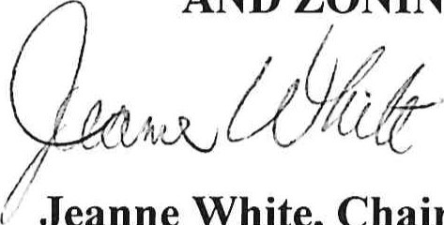

Jeanne

White,

Chairwoman

ATTEST:

Ann Marie Weitzel

## CERTIFICATION

I hereby certify the foregoing resolution is a true memorialization of the Board action to appoint a Board Secretary at a regular meeting of the Elk Township Combined Planning and Zoning Board held on Wednesday, May 19, 2021

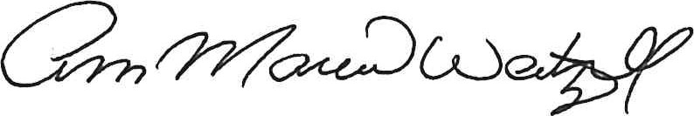

Ann Marie Weitzel, Board Secretary